Contents

What is RDP? 3
Basic Security Tips for Remote Desktop 3
Use strong passwords 3
Enable Network Level Authentication 3
Limit users who can log in using Remote Desktop 4
Set an account lockout policy 4
Change the listening port for Remote Desktop 5
Use RDP Gateways 6
Tunnel Remote Desktop connections through IPSec or SSH 6
Allow only certain IP addresses to access the Remote Desktop. 7
References 7

What is RDP?
Remote Desktop Protocol is a proprietary protocol created by Microsoft. It allows a system user to connect to a remote system with a graphical user interface. The client-side agent is built into the Microsoft operating system by default, but can be installed on non-Microsoft operating systems, such as those from Apple, various flavors of Linux, and even mobile OSes like Android
The server-side portion of RDP is installed on a Microsoft operating system and receives requests from the client agents to display some graphical form of a published application, or remote access to the system itself. By default, a system will listen on port 3389 for requests from clients to connect via the RDP.

Basic Security Tips for Remote Desktop

Use strong passwords

Use a strong password on any accounts with access to Remote Desktop. This should be considered a required step before enabling Remote Desktop.
Passphrases MUST:
- Contain nine characters or more
- Contain characters from two of the following three character classes:
  - Alphabetic (e.g., a-z, A-Z)
  - Numeric (i.e. 0-9)
  - Punctuation and other characters (e.g., !@#$%^&*()_+|~-=\`{}[]:";'<>?,./)

Enable Network Level Authentication

Windows Vista, Windows 7, and Windows Server 2008 also provide Network Level Authentication (NLA) by default. It is best to leave this in place, as NLA provides an extra level of authentication before a connection is established. You should only configure Remote Desktop servers to allow connections without NLA if you use Remote Desktop clients on other platforms that don't support it.
Enabling NLA on Windows 2012 Server, Windows 8, and Windows 10:
- NLA should be enabled by default on Windows 2012 Server, Windows 8, and Windows 10.
- To check you may look at Group Policy setting Require user authentication for remote connections by using Network Level Authentication found at Computer\Policies\Windows Components\Remote Desktop Services\Remote Desktop Session Host\Security. This Group Policy setting must be enabled on the server running the Remote Desktop Session Host role.

Limit users who can log in using Remote Desktop

By default, all Administrators can log in to Remote Desktop. If you have multiple Administrator accounts on your computer, you should limit remote access only to those accounts that need it. If Remote Desktop is not used for system administration, remove all administrative access via RDP and only allow user accounts requiring RDP service. For Departments that manage many machines remotely, remove the local Administrator account from RDP access at and add a technical group instead.
- Click Start-->Programs-->Administrative Tools-->Local Security Policy
- Under Local Policies-->User Rights Assignment, go to "Allow logon through Terminal Services." Or “Allow logon through Remote Desktop Services”
- Remove the Administrators group and leave the Remote Desktop Users group.
- Use the System control panel to add users to the Remote Desktop Users group.

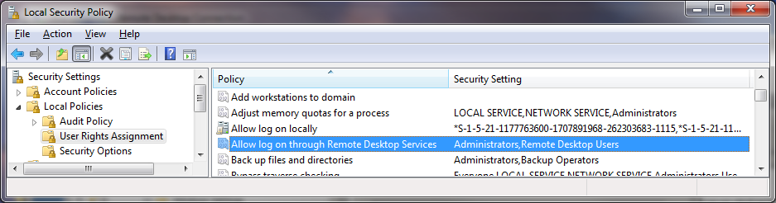

Set an account lockout policy

By setting your computer to lock an account for a period of time after a number of incorrect guesses, you will help prevent hackers from using automated password guessing tools from gaining access to your system (this is known as a "brute-force" attack). To set an account lockout policy:
- Go to Start-->Programs-->Administrative Tools-->Local Security Policy
- Under Account Policies-->Account Lockout Policies, set values for all three options. 3 invalid attempts with 3 minute lockout durations are reasonable choices.

Change the listening port for Remote Desktop

Changing the listening port will help to "hide" Remote Desktop from hackers who are scanning the network for computers listening on the default Remote Desktop port (TCP 3389). This offers effective protection against the latest RDP worms such, as Morto. To do this, edit the following registry key (WARNING: do not try this unless you are familiar with the Windows Registry and TCP/IP): HKEY_LOCAL_MACHINE\SYSTEM\CurrentControlSet\Control\Terminal Server\WinStations\RDP-Tcp. Change the listening port from 3389 to something else and remember to update any firewall rules with the new port.
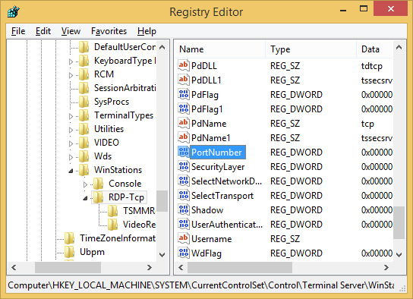
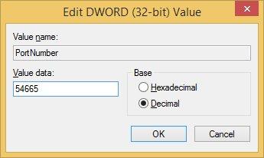

Use RDP Gateways

Using a RDP Gateway is strongly recommended. It provides a way to tightly restrict access to Remote Desktop ports while supporting remote connections through a single "Gateway" server. When using an RD Gateway server, all Remote Desktop services on your desktop and workstations should be restricted to only allow access only from the RD Gateway. The RD Gateway server listens for Remote Desktop requests over HTTPS (port 443), and connects the client to the Remote Desktop service on the target machine.

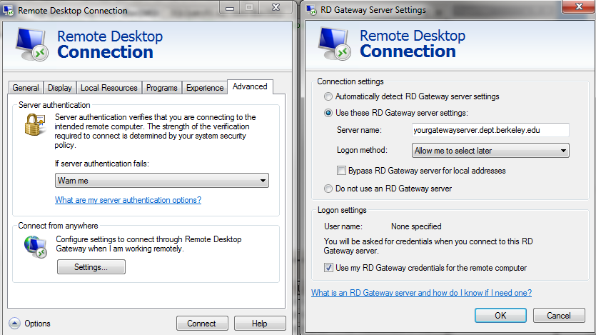

Tunnel Remote Desktop connections through IPSec or SSH

If using an RD Gateway is not feasible, you can add an extra layer of authentication and encryption by tunneling your Remote Desktop sessions through IPSec or SSH. IPSec is built-in to all Windows operating systems since Windows 2000, but use and management is greatly improved in Windows Vista/7/2008 (see: http://technet.microsoft.com/en-us/network/bb531150(link is external)). If an SSH server is available, you can use SSH tunneling for Remote Desktop connections. .

Allow only certain IP addresses to access the Remote Desktop.

IP addresses are a unique series of numbers that identifies a computer, and through Windows it is possible to limit the Remote Desktop Connection to only known and trusted IP addresses. To do so, navigate to your Windows Firewall settings through the Windows Control Panel. In the Firewall options, select the Exceptions tab and highlight Remote Desktop. Click the edit button followed by the Change Scope button.

This screen gives you the option to limit access to a local network, or create a custom list of IP addresses that are allowed access. Enter the IP addresses and click OK. Your Remote Desktop is now secure.

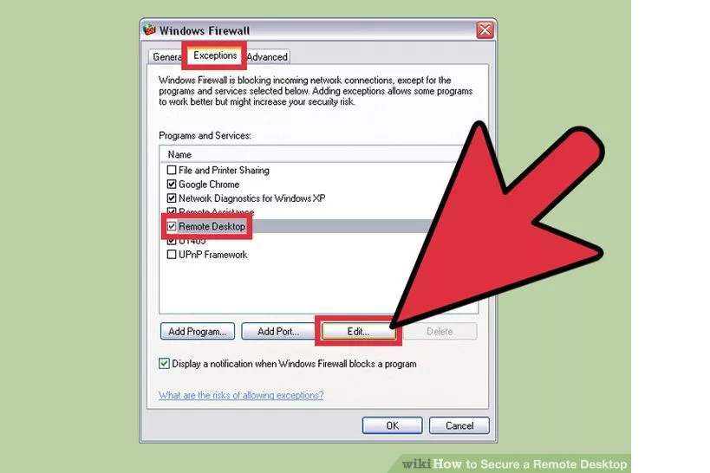

References

http://www.wikihow.com/Secure-a-Remote-Desktop
http://www.howtogeek.com/175087/how-to-enable-and-secure-remote-desktop-on-windows/
https://security.berkeley.edu/resources/best-practices-how-articles/securing-remote-desktop-rdp-system-administrators
http://huagati.blogspot.com/2014/02/blocking-rdp-brute-force-logon-attacks.html

